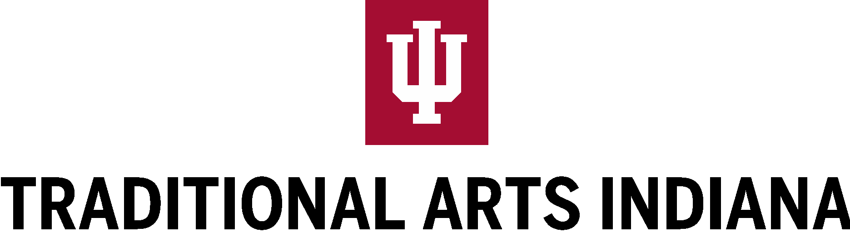

TAI Apprenticeship Program Application

Application Deadline: October 31, 2023

Apprenticing with a master artist is a time-honored way of passing on traditional arts. As a way to complement this process, the Traditional Arts Indiana (TAI) Apprenticeship Program will support up to six apprenticeship pairs in 2024 year, enabling apprentices to learn essential knowledge and skills in traditional art forms from master artists.

Please read through this application and review your eligibility before applying to the TAI Apprenticeship Program. Master artists and apprentices must fill out application questions and mail in a printed copy in addition to a work sample and separate letters of support before the deadline, October 31, 2023.

Traditional Arts Indiana
TAI was established in 1998 as a partnership between Indiana University Bloomington (IU) and the Indiana Arts Commission (IAC). Traditional Arts Indiana and its programming are currently funded in part by the National Endowment for the Arts (NEA).

TAI is dedicated to expanding public awareness of Indiana’s traditional practices and nurturing a sense of pride among Indiana’s traditional artists. TAI identifies, documents, and seeks to understand more fully the many ways in which cultural values are embedded and expressed in daily life. It calls attention to neglected aesthetic forms that firmly ground and deeply connect individuals to their communities–from the spoken text to the hand-made object to customary behavior. TAI’s overarching goal is to integrate and connect cultural practices to educational activities, cultural conservation, arts, and community development at the local, state, and national levels.

What are Traditional Arts?
The TAI Apprenticeship Program supports traditional cultural expressions of a community or group. Examples might be making an object, playing a tune, or practicing a dance. Nevertheless, each creative practice is rooted in a community. It is “traditional” in that it entails skills, aesthetics, and values that are transmitted over time within a family, community, religious, or occupational setting. Within these groups, master artists are individuals who are formally or informally recognized for excellence in their artistic traditions and communities. Traditionally, folk arts are not completely self-taught nor learned in a formal educational setting. Rather traditional knowledge is transmitted through mentorship, observation, and practice withing specific groups and networks of people.

Expectations of Apprenticeship Pairs
If selected, master artists will receive an honorarium of $3,000, with additional funds to cover the cost of apprenticeship materials and resources. Each master artist will host an apprentice formally for nine months to teach culturally significant knowledge and skills necessary for the continued practice of traditional art forms.

TAI fieldworkers will visit apprenticeship pairs in the artists’ home communities to conduct interviews, take photographs, and document the apprenticeship using audio and video recordings. At the end of the apprenticeship period, pairs will demonstrate their traditional art forms at an event hosted at Indiana University in Bloomington. Details of this event will be determined at a later date. Additionally, apprenticeship pairs will be required to participate in an organized event for their local community.

Apprenticeship pairs will be featured in the Rotating Exhibit Network (REN), TAI’s traveling exhibition program. Since 2005, the REN panels have toured libraries throughout Indiana, exhibiting photographs and biographies of Indiana artists and musicians to the greater public. The REN panels reach over 130,000 people during an annual rotation. At the end of the apprenticeship cycle, TAI will create a series of video shorts that feature the work of each apprenticeship pair.

Adjudication Process
Applications, work samples, and letters of support will be reviewed by a panel of traditional arts specialists. Competitive applicants will be able to explain how their art form is a continued tradition. Master artists must be able to demonstrate excellence in their artistic traditions through submitted work samples. Finally, applicants must explain how their artistic tradition is significant within their cultural community.

Eligible applicants must be residents of Indiana at the time of application. Funding Support
This project is made possible through funds received from the National Endowment for
the Arts (NEA) and the Indiana Arts Commission (IAC) with administrative support from Indiana University Bloomington. This program is contingent upon continuation of funds from both the NEA and the IAC.

Accessibility
TAI intends this program to be available to all. Please let us know if there are any specific needs for translation or application assistance.

Application Timeline

October 31 Application and all supporting materials due
November 17 Review panel meets
December 31 (or before) Applicants notified

Questions? Contact TAI Director Dr. Jon Kay: jkay@indiana.edu or (812) 855-0418.

PART A. MASTER ARTIST AND APPRENTICE INFORMATION

Master Artist

Name

Address

City Zip code County
Date of Birth _________________ Preferred Phone Number
Email Address Website URL Are you a member of a federally recognized tribe? (Check one) Yes No
If yes, please identify your affiliation.

Apprentice

Name

Address
City Zip code County
Date of Birth Preferred Phone Number
Email Address
Website URL
Are you a member of a federally recognized tribe? (Check one) Yes No

If yes, please identify your affiliation.

PART B. MASTER ARTIST QUESTIONNAIRE

- What is the traditional art you wish to teach? Please describe.

- How and when did you learn this tradition?

- What role does this tradition play in your community? Please describe its historical significance to your community. *

* “Community” refers to the specific group where a traditional art is practiced. Traditional art forms are often rooted in local life and/or an occupational, religious, and family practice.

- Explain why this tradition is important to you and why you would like to participate in the TAI Apprenticeship Program.

- Have you taught this traditional art to anyone in the past? Who? When?

- Describe your relationship to your proposed apprentice. Have you worked together before?

- What specifically do you hope to accomplish during this apprenticeship? What knowledge and skills do you plan to impart to your apprentice?

- What milestones, recognitions, awards, or other accomplishments have you achieved that relate to your traditional art?

- Please list two people who will be submitting letters of support for your application.

  - Name

Relationship

  - Name

Relationship

PART C. APPRENTICE QUESTIONNAIRE

- Please describe the traditional art you wish to learn.

- Do you currently have any experience in this traditional art? Please describe.

- Describe your relationship to the master artist and why you want to work with them.

- What interests you about this tradition?

- In your own words, why is your knowledge of this tradition important to you and your community?

- What are your plans for practicing this traditional art after the apprenticeship?

PART D: APPRENTICESHIP WORK PLAN
(For the master artist to fill out)

- What specific skills and techniques will be taught to the apprentice?

- What goals will you and your apprentice achieve through this apprenticeship?

- What communities do the apprentice and master artist share? (These can include ethnic groups, religious groups, tribal affiliation, occupation, etc.)

- How often will you and your apprentice meet? Where and for how long? Please outline your proposed schedule. We understand that this schedule is tentative and subject to change.

- What items or resources will need to be purchased or acquired for this apprenticeship to be successful? Please list the materials you will need including estimated expenses.

- This apprenticeship program requires that you demonstrate your traditional art with your apprentice in your local or cultural community. What do you expect or prefer this event to be? (i.e., concert, demonstration, exhibition, and/or workshop). Is there a venue where you would like to host this program?

PART E: WORK SAMPLE DESCRIPTION PAGE
In the space provided describe your included work sample. Up to 10 work samples are allowed. Name each work sample with the corresponding number. In addition to the Master artists samples, the apprentice may submit one optional work sample.

WORK SAMPLE #1
Title:
Type of media (photograph, MP3, video, weblink, etc.): Description:

WORK SAMPLE #2
Title:
Type of media: (photograph, MP3, video, weblink, etc.): Description:

WORK SAMPLE #3
Title:
Type of media (photograph, MP3, video, etc.): Description:

WORK SAMPLE #4
Title:
Type of media (photograph, MP3, video, etc.): Description:

WORK SAMPLE #5
Title:
Type of media (photograph, MP3, video, etc.):
Description:

WORK SAMPLE #6
Title:
Type of media (photograph, MP3, video, etc.): Description:

WORK SAMPLE #7
Title:
Type of media (photograph, MP3, video, etc.): Description:

WORK SAMPLE #8
Title:
Type of media (photograph, MP3, video, etc.): Description:

WORK SAMPLE #9
Title:
Type of media (photograph, MP3, video, etc.): Description:

WORK SAMPLE #10
Title:
Type of media (photograph, MP3, video, etc.): Description:

OPTIONAL APPRENTICE WORK SAMPLE
Title:
Type of media (photograph, MP3, video, etc.): Description:

REQUIRED DOCUMENTS CHECKLIST

The following materials are a required part of your application. Be sure to review your materials before you submit your application.

- Completed, signed application
- Written answers for Master Artist, Apprentice, and Work Plan
- Work sample – one set, not to exceed 10 samples

  - Sample may include: photographs of artwork, video documentation, audio recordings, and YouTube links as applicable. Submit on CD, Flash drive or website URL link.
  - Part E: Work Sample Description Page
  - Reviewers may only review up to ten minutes of supplied recorded media. Please indicate the section you want to be reviewed. Provide the beginning and ending time code.
  - 1 optional work samples from apprentice.
- Letters of Support

  - Two letters from community members, professional contacts, or other individuals who know the work of the applicant and can comment on the applicant’s artistic mastery. References can address the applicant’s traditional knowledge and skills, cultural ties to the community, and the importance of this traditional art.

  - Letters of support should be signed and mailed by postmark date to Jon Kay at Traditional Arts Indiana. Electronic copies of signed letters of support may also be emailed to jkay@indiana.edu.

SUPPORT MATERIALS HANDLING

Please select one of the following options for handling your support materials after review is complete. TAI will retain the support materials of teams that receive an award. Please do not mail original artwork. Check one:

- Destroy my materials after review

- Mail my support materials back to me (if chosen, please include an enclosed, stamped, self-addressed envelope)

RESIDENCY REQUIREMENT
By signing the application in the space provided below, you are certifying that you have established residence and have been living in Indiana for at least one year prior to the date of application. Awardees must maintain Indiana residency during the apprenticeship. Proof of residency may be required.

Master Signature: Date:

Apprentice Signature: Date:

Mail application and accompanying materials to:

Jon Kay Traditional Arts Indiana
Cook Center for Public Arts and Humanities Maxwell Hall 026
750 E Kirkwood Ave Bloomington, IN 47405

The TAI Apprenticeship Program is supported by:

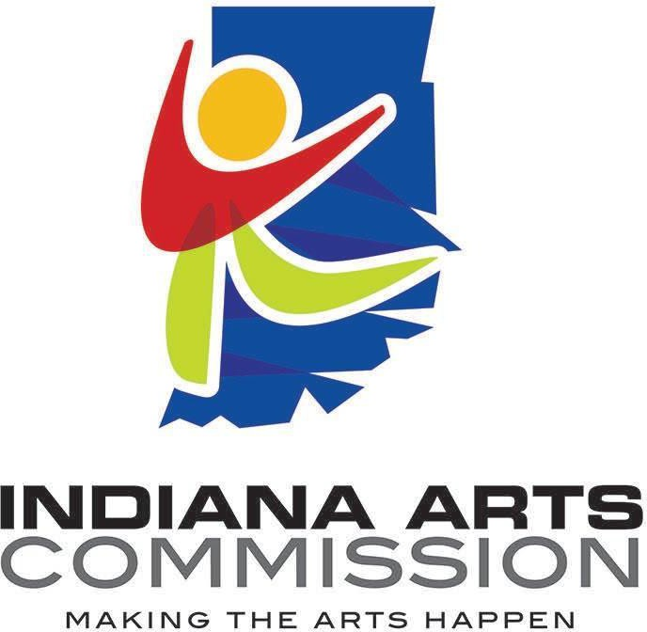
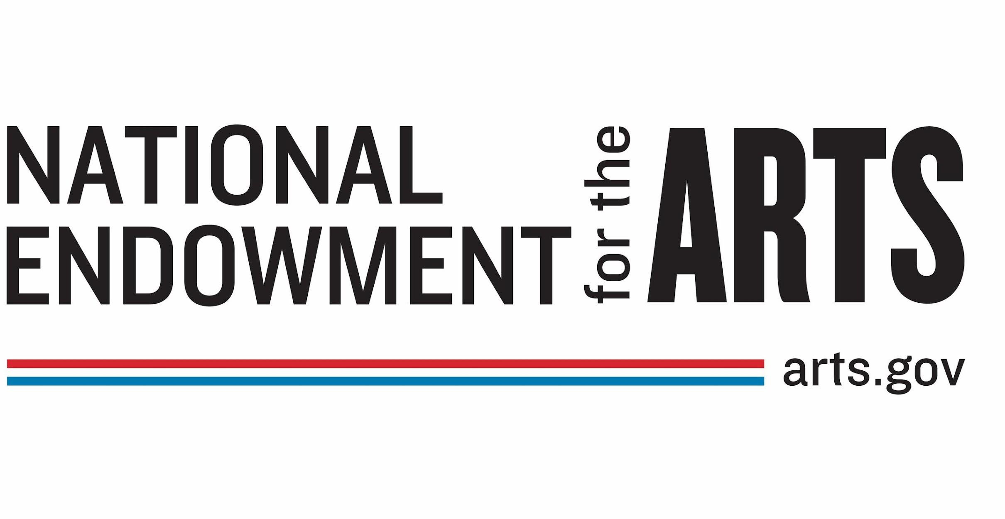
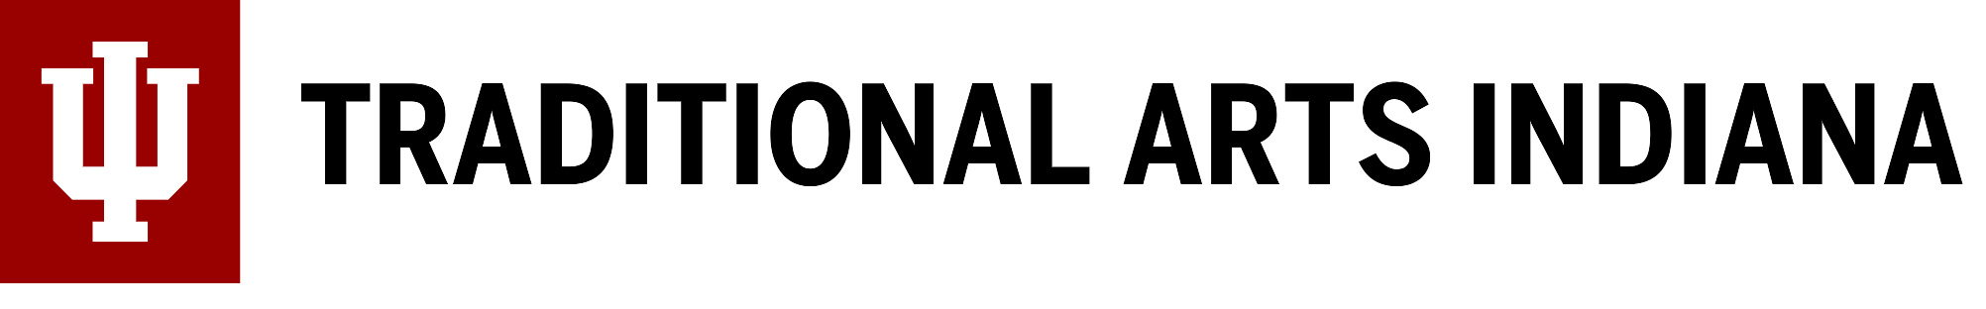

Updated 07/26/2023

